**CLOUD COMPUTING DAY-3 QUESTIONS**

# USING AZURE

**18.Create a Storage service using any Public Cloud Service Provider (Azure/GCP/AWS) and check the public accessibility of the stored file to demonstrate Storage as a Service.**

**Procedure:**

1. From 17 question we did only to create an storage account.
2. After to keep the file cloud access
3. If we keep like this anywhere anybody,anyperson can access the file same file.

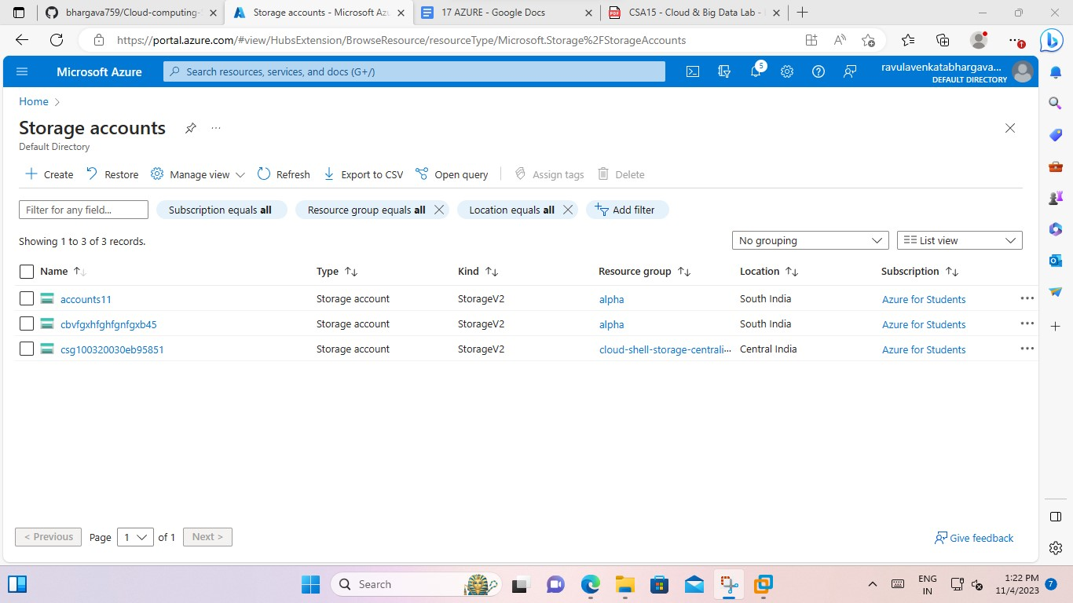

4.And goto file service the create the directory of the file.

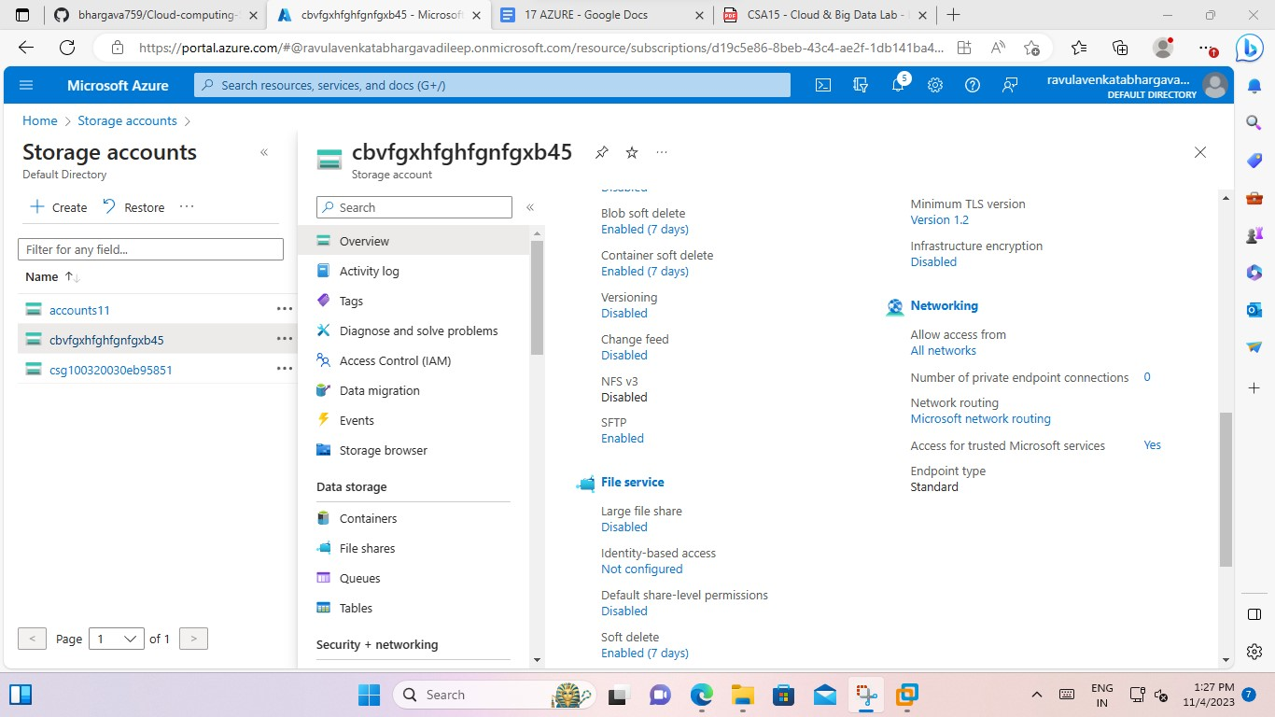

5. If we click the file service then create the directory.

-> then create option for “file share”

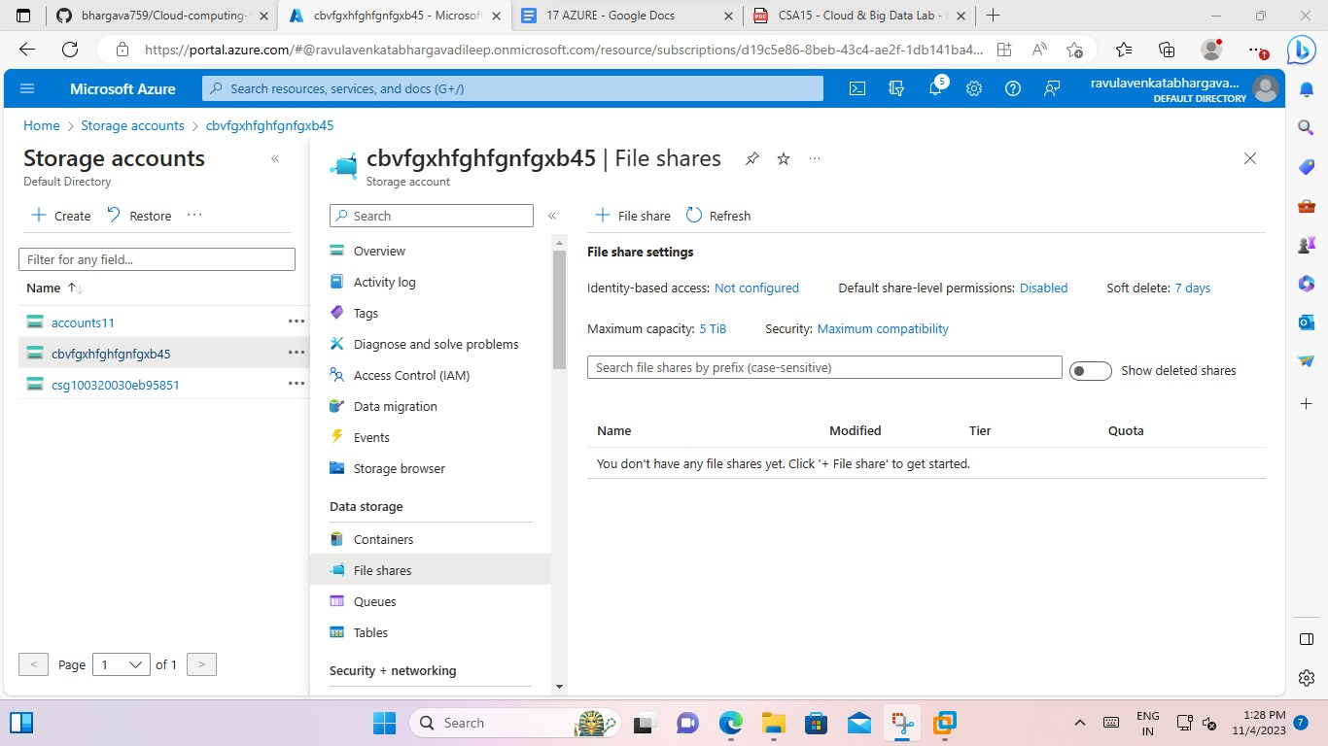

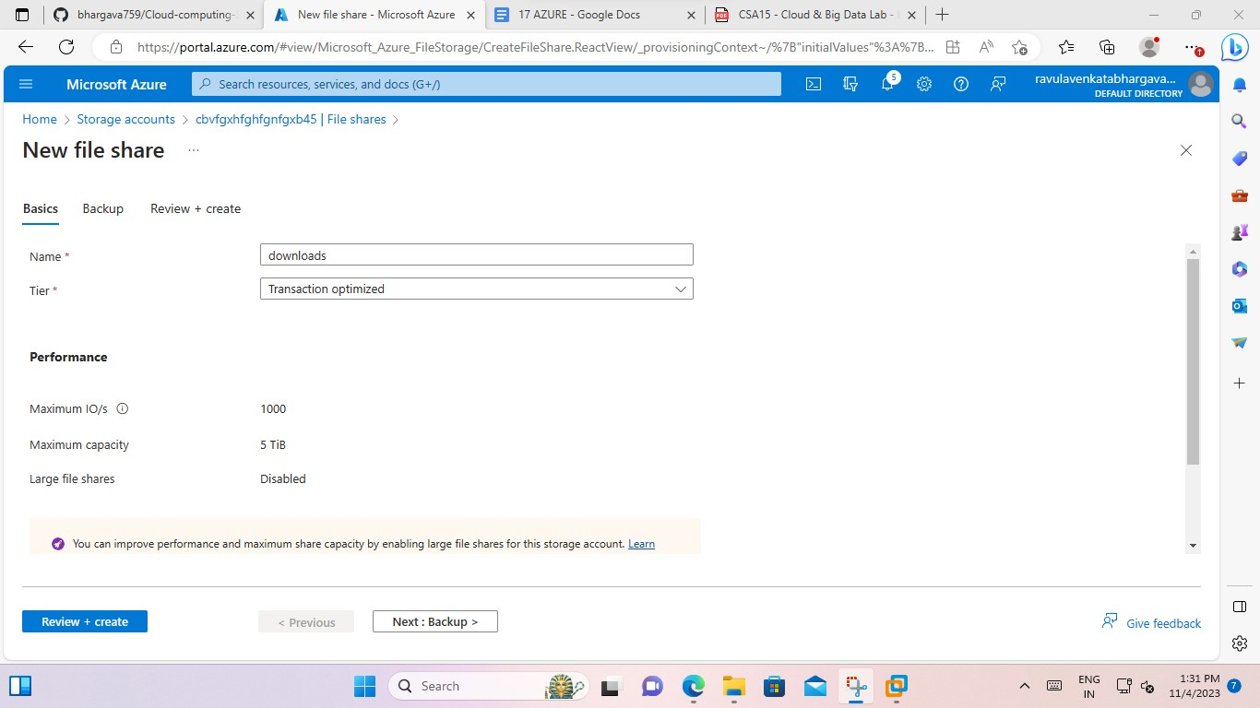

6.To tap create button.

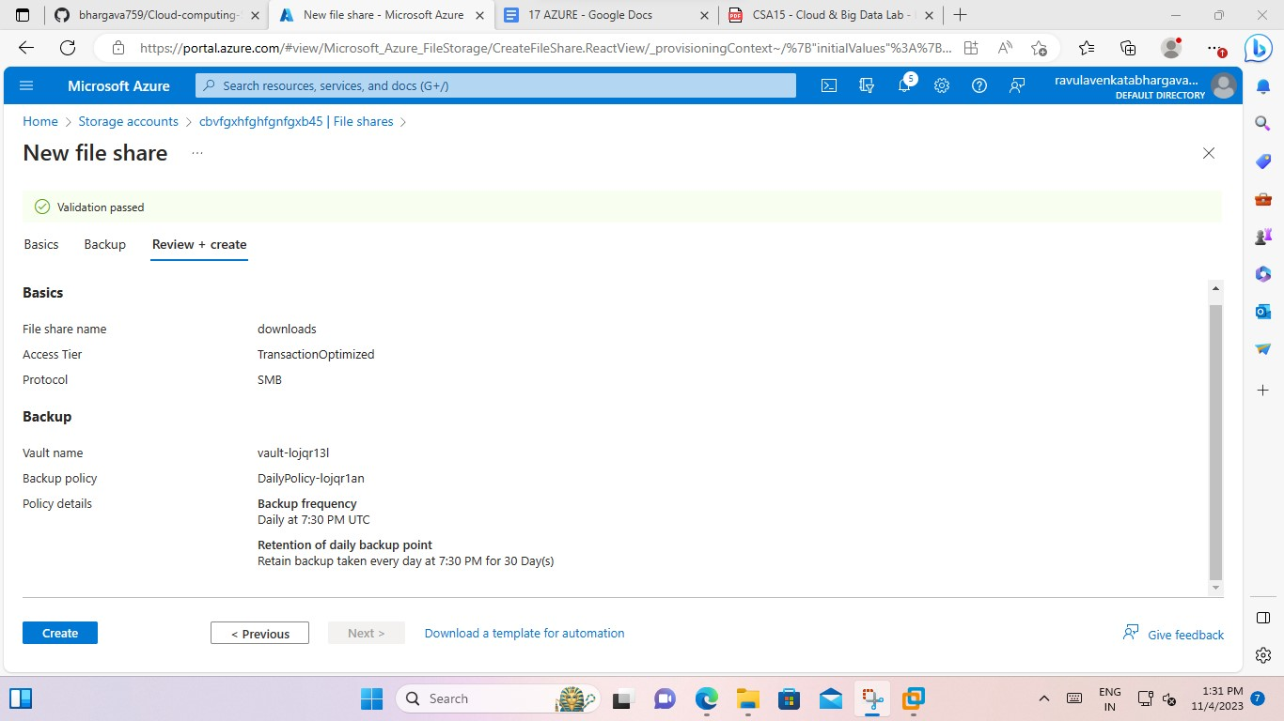

7.And tap refresh

And tap the upload option and then click the ok button.

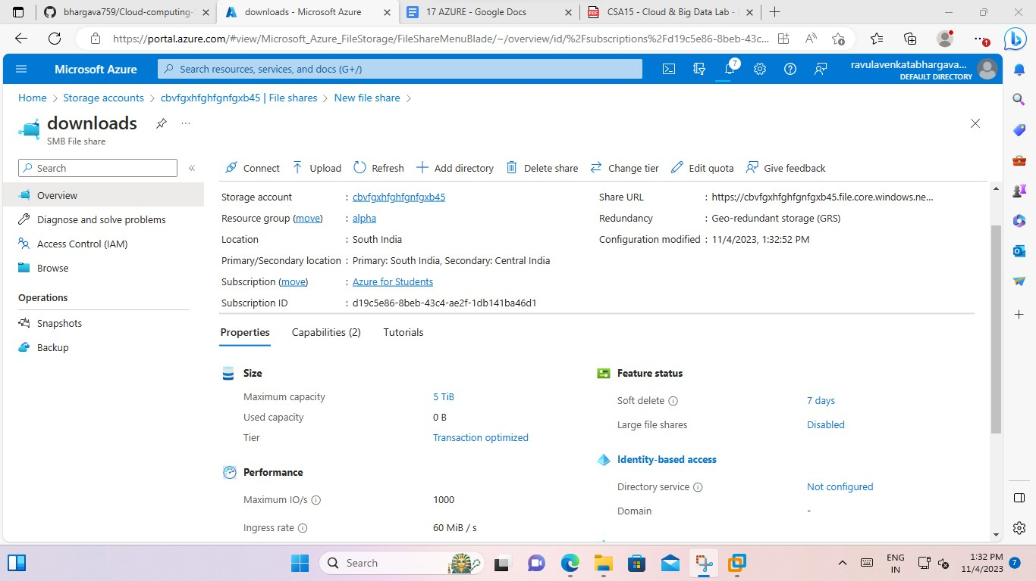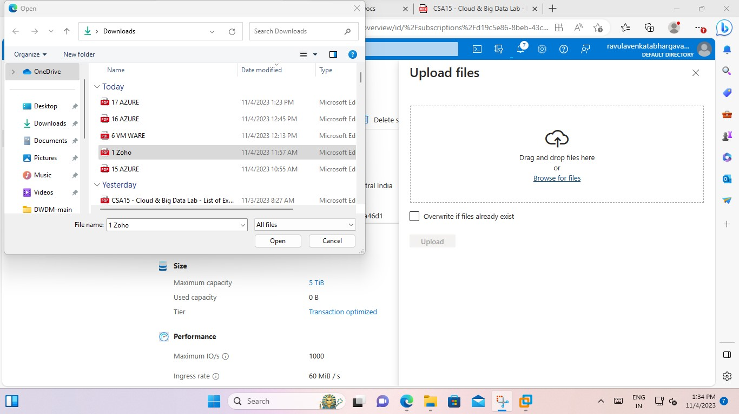

8.after uploading it shows msg successful added the file

